Victims’ Code awareness survey

Aim
The Victims’ Code in the UK outlines the rights and support services every victim of crime can expect from criminal justice agencies in England and Wales. It ensures they are informed and treated with respect, offering rights like understanding the process, accessing support, making a Victim Personal Statement, and complaining if rights aren’t met. This is reinforced by new legislation such as the Victims and Prisoners Act 2024.
Throughout 2026 – 2028, the OPCC will be carrying out activity to build awareness of the Victims’ Code and victims’ rights within that code. This survey has been conducted to provide a baseline for the current levels of awareness and knowledge of the Victims’ Code across the West Midlands. The aim was to collect 100 responses per LPA.

Method
The survey was promoted on social media on 6th January 2026, with a single post on X, Facebook, and LinkedIn. In person surveying took place between 12th – 19th January 2026. The survey was closed at 09:00 on 20th January 2026.
The survey was built within ArcGIS. OPCC staff spoke to members of the public and then inputted their answers into the survey via tablets. The survey questions can be found in Appendix 1, and copies of the social media posts in Appendix 2.

Results
Between 6th-19th January, 819 people were surveyed on their awareness of the victims’ code. There were 15 responses prior to the in-person surveying beginning on 12th January, therefore, it can be assumed that those 15 responses came online, via the social media posts. Given a week had passed between the social media posts and the in-person surveying commencing, the traction and visibility of these posts would have significantly reduced. Therefore, this would indicate that most of the remaining results came from the in-person surveying.

Overall awareness of the Code
When asked ‘have you heard of the Victims’ Code before?’, 95% of people said no, with 5% of respondents saying yes.

For those who said they were aware of the Victims’ Code, they were then asked to describe what they thought the Code is.
Of the 41 respondents who answered yes to having heard of the Victims’ Code, 34 free text replies were entered in answer to describing what they thought the Victims’ Code is. These responses indicated that 22 respondents had some demonstrable knowledge of the Victims’ Code, including comments such as, ‘about how the police contact you after a crime and how the courts deal with you’, ‘helps all victims, regardless of crime, to identify their rights’ and ‘help victims navigate the justice system’.
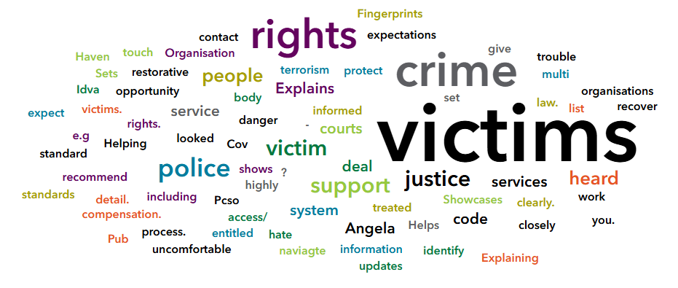
Of the remaining 12 respondents who said yes to having heard of the Victims’ Code, they did not demonstrate knowledge of the code when asked to describe it. Some of the comments included, ‘I have heard of it, but I’m not sure what it does’, ‘an organisation to protect victims’ and ‘how to get in touch with the police’. Interestingly, 2 people believed it was ‘Ask for Angela’.
A word cloud below shows some of the different words used in describing the Victims’ Code.

Awareness of the Code by LPA

When responses were broken down by LPA, the awareness of the Victims’ Code remained low across each region, with between 89% and 98% of respondents stating that they did not know what the Victims’ Code was. Coventry LPA, with 11% (12), had the highest number of respondents who did state they knew what the Victims’ Code was.
The results indicate that awareness of the Victims’ Code is very low across all areas of the West Midlands, and there is no strong relationship between awareness of the Victims’ Code and the region of the West Midlands the respondent lived.

Awareness of the Code by age group

The results indicate that the awareness of the Victims’ Code is low across all age groups. The youngest and oldest members of the population (under 18, 18-24, and 75 and over) were the groups least likely to know about the Victims’ Code.
Whilst those aged 45- 54 year’s old were most likely to have heard about the Victims’ Code – the results do not indicate a strong relationship between those aged 25-44 and 55-75 and over and their levels of awareness.

Awareness by sex
The results indicate that the awareness of the Victims’ Code is low across all sexes, with just a 2% difference between female and male.
The percentages appear higher in the ‘prefer not to say’ column due to the small number of respondents who gave that answer. There were 11 respondents who said no, and 1 respondent who said yes.

Conclusion
This survey aimed to provide a baseline for the levels of awareness and knowledge of the Victims’ Code across the West Midlands. The survey showed that the awareness and demonstrable knowledge of the Victims Code is very low (5% of respondents).
It was anticipated that the awareness of the Victims’ Code would be low, and due to this low awareness, there were no meaningful trends identified within age group or sex on who and who wasn’t aware of the Victims’ Code.

Appendices

Appendix 1
The survey comprised of 5 questions:
- Have you heard of the Victims’ Code before?
  - (If yes) Please describe what you think the Victims’ Code is.
- Where do you live in the West Midlands?
- What is your sex?
- What is your age?

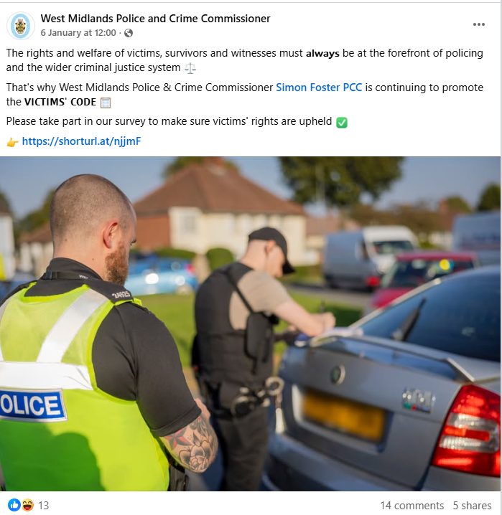
Appendix 2
