

Stop and Search Scrutiny Panel
Data covering July and August 2015

E- Search Data

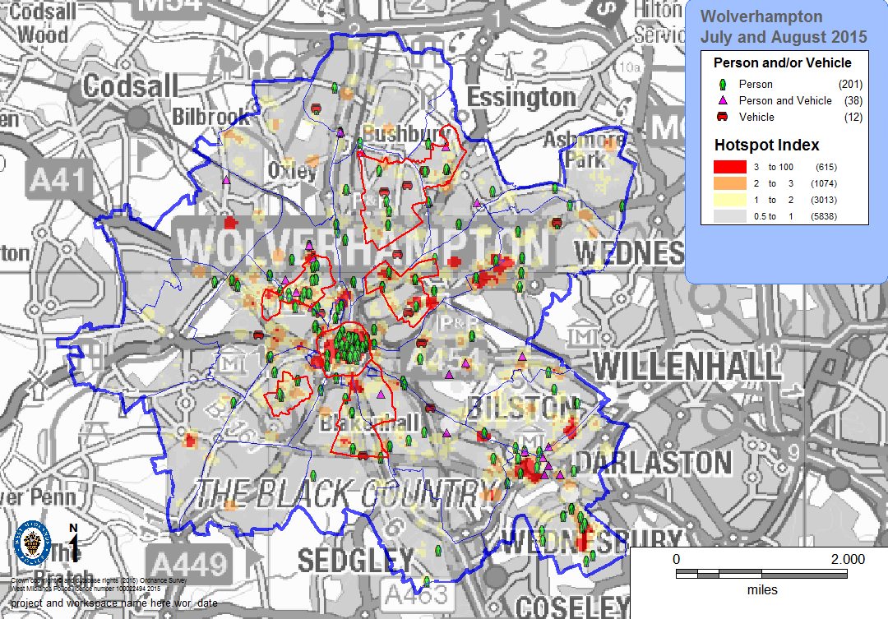

The above map details the number of stop searches and Total recorded crime hotspots for July and August 2015. The priority areas for the LPU are also identified.

Total Recorded Stop Searches

The above chart details all recorded stop searches since 1st April 2013. The LPU saw an increase in the number of stop and search conducted in July 2015 followed by a slight reduction during August.

The above table details the total number of recorded stop searches over the last 12 months as detailed in the chart above. There has been a reduction in the number of searches conducted of 45 in August compared to July; however there has been an increase of 34 compared to August 2014.

The above table details the number of stops conducted by district area each month.
The city centre continues to see the largest number of stops conducted during the period November through to August followed by Whitmore Reans and Wednesfield.
Outcomes

The above table details the outcomes for the searches conducted. The number of positive outcomes has seen a reduction in July compared to June followed by an increase once again in August remaining consistent at 28%.

The above chart illustrates the outcomes for July and August 2015 as detailed in the table above.

The above table illustrates the object description and the how the offence was then dealt with during July and August. The largest offence type dealt with was for drug offences accounting for 58.6% of the total of which 77% of drug offences resulted in NFA.

Custody

The above table identifies the number of custody records created as a result of stop search. During July there have been 6 Custody records created of which 2 require an e-search record to be completed, in August there have been 11 custody records created of which 8 require an e-search record to be completed.

A review is conducted each month as to the reason why no e-search record has been completed two of the responses in relation to July and August are listed below

Reason for no e-search record

- Not required, not as a result of Stop & Search but investigation. Harj Singh
- Not required, not as a result of Stop & Search but investigation. Nick Shee
- Not required, not as a result of Stop & Search but investigation. Lee Hayward
- This is an arrest sus Shop Theft on intel from security by reading the custody record followed by a Sect.32 search
- Offender seen and arrested wanted on PNC, NO STOP AND SEARCH was conducted. (booked in by a DEO)
- Not a result of a stop and search. Arrested prior to search
- This was an ANPR Operation where a routine check was carried out on the person who was found to be in the country illegally. It was not as a result of a stop and search

There remains an issue with custody officers when completing the custody record marking the record as a result of stop and search. Feedback has been provided via the service improvement meeting.

The above chart details each month the number of custody records where no e-search record has been completed.
Stop forms not reaching Standard

The above table illustrates the number of records that do not meet the required standard. During July and August there have been 7 records submitted that does not meet the required standard.

Reasons for not meeting required standard:

July 2015

- There is not enough detail for the grounds of search - 'acting sus' is not enough
- References drugs, and handing objects but then states sect 1 pace re stolen items...s23 m.d.a would seem the correct power?
- Male matched description required more detail as to why not arrested. Male had one item of clothing that matched, but upon further investigation male was negated from robbery.
- The grounds for the stop and search do not meet the criteria.
- Being aware of the circumstances of this search, the officer has failed to record full justification for the grounds of the search i.e. the person searched is the partner of a male who was believed to be in possession of a firearm and was arrested & searched for this firearm. No firearm was found on the male and the person subject to this record was a passenger in a vehicle that the male was known to have been in and the vehicle was subject to a Sec 18(5) PACE search following the male's arrest.
- States male known for drug use and consented to search, although the male did smell of cannabis, so there are grounds to search this male, although the wording on this does not read correctly.

August 2015

- Officers info provided believed to have been abbreviated. Officers attended scene where males were seen to make off, based on their behaviour and description they were searched for stolen items. Further info established at scene resulted in his arrest as well as keys found in person.

Ethnicity

The above table details against the census data the number of searches completed and the disproportionality. During July and August there were less White ethnicity and Asian ethnicity persons stopped compared to the expected numbers and more of Black ethnicity persons compared to the expected numbers.

The above table details the ethnicity of the person stop searched and the outcome of the search during July and August. Of the 35 people arrested following the stop search, 20 were of White ethnicity (British or Other), 3 were of Mixed ethnicity (White and Black Caribbean, Other), 6 were of Black or Black British (Caribbean, Other ethnicity), 5 were of Asian or Asian British (Indian ethnicity). 1 recorded as not applicable

