

Stop and Search Scrutiny Panel
Data covering May and June 2015

E- Search Data

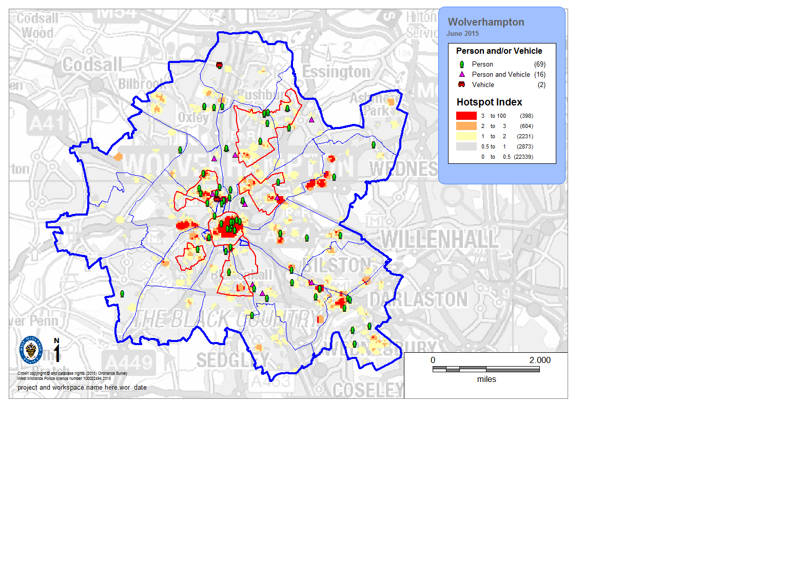

The above map details the number of stop searches and Total recorded crime hotspots for June 2015. The priority areas for the LPU are also identified.

Total Recorded Stop Searches

The above chart details all recorded stop searches since 1st April 2013. The LPU saw an increase in the number of stop and search conducted in May 2015 in part due to a football match on the LPU.

The above table details the total number of recorded stop searches over the last 12 months as detailed in the chart above. There has been a reduction in the number of searches conducted of 52 in June compared to May.
This however will be due in part to the increased number of searches conducted using the Section 60 power on the 2nd May because of the football match which accounted for 31 of the searches conducted.

The above table details the number of stops conducted by district area each month.
The city centre sees the largest number of stops conducted during the period November through to June followed by Whitmore Reans and Wednesfield.
Outcomes

The above table details the outcomes for the searches conducted. The number of positive outcomes has remained consistent in June when compared to May.

The above chart illustrates the outcomes for June 2015 as detailed in the table above.

The above table illustrates the object description and the how the offence was then dealt with during May. The largest offence type dealt with was for drug offences accounting for 48.9% of the total.

The above table illustrates the object description and the how the offence was then dealt with during June. The largest offence type dealt with was for drug offences accounting for 58.6% of the total.
Custody

The above table identifies the number of custody records created as a result of stop search. During June there have been 11 Custody records created of which 5 require an e-search record to be completed equivalent to 45% of the total.

A review is conducted each month as to the reason why no e-search record has been completed two of the responses in relation to June are listed below

Reason for no e-search record

- Known person seen by officers, PNC confirmed as wanted – officers then approached PIC notified them they were wanted, arrest made. No E-search record required
- Searched under 32 PACE following arrest for a knife but this does not qualify as a stop/search

The above chart details each month the number of custody records where no e-search record has been completed.
Stop forms not reaching Standard

The above table illustrates the number of records that do not meet the required standard. During May there have been 24 records submitted that does not meet the required standard this is due to the increased number submitted with the use of the Section 60 power.
In June there have been 4 records submitted that does not meet the required standard.

Reasons for not meeting required standard:

May 2015
- Section 60 Object details are incorrect - Data input error (each of the 24 records)

June 2015
- Insufficient detail within the grounds (each of the 4 records)

Ethnicity

The above table details against the census data the number of searches completed and the disproportionality. During June there were less White ethnicity and Asian ethnicity persons stopped compared to the expected numbers and more of Black ethnicity and Mixed ethnicity persons compared to the expected numbers.

The above table details the ethnicity of the person stop searched and the outcome of the search during June. Of the 16 people arrested following the stop search, 8 were of White ethnicity (British or Other), 3 were of Mixed ethnicity (White and Black Caribbean), 3 were of Black or Black British – Caribbean ethnicity, 1 was of Asian or Asian British – Pakistani ethnicity and 1 was of Asian or Asian British – Indian ethnicity.

Repeat Stops
The above table has been created as a result of the group asking for greater detail in respect of repeat searches and as a result the extra information that has been requested has been placed into the above table to assist the scrutiny of the repeat stops.

The table will need to be used in conjunction with the search forms related to the individual to ensure the overall picture is capture.
LPU Comparison

The following data is a comparison of stop search outcomes and ethnicity across the 10 LPUs within West Midlands Police. The data covers the period 1st March 2015 – 31st May 2015

