Walsall Strategic Community Reference Group
Minutes of meeting held on Thursday 3 September 2015 at Walsall Police Station.
In attendance:
Nirmal Singh (NS) (Chair) Sikh Forum
Bill Ellens (BE) CUSP
Cllr. Rose Burley (RB) Councillor Bentley/Darlaston North
Ken Ferguson (KF) Brownhills Committee
Afftar Ali (AA) Wolverhapton Uni Students Union
Mahmood M Sacha (MS) Muslim Welfare Society/UMO
Mr R K Mehmi (RM) SGRTD
Sandeep S Sohal (SS) Sikh Forum
PC Gavin Nixon (GN) WM Counter Terrorism Unit
Kelly Monaghan (KM) Walsall Police
Amanda McPhee (AM) Walsall Police
Kevin Pitt (KP) Walsall Police

Apologies:
Vasant Mistry
Elizabeth Vodden
Ryan Steane
Imran Sacha
Cllr A Ditta
Martin Hurcomb

Minutes of Last Meeting.
It was asked if it would be possible to re-arrange the child exploitation talk for a future meeting.

ACTION – KP to schedule talk at a future meeting.

KP explained that he had been unable to obtain the expanded hate crime information from his usual source. AM suggested that it would be possible to extract more detailed information from the strategic assessment and this will be investigated for future meetings.

Prevent – Counter Terrorism Unit
PC Gavin Nixon introduced himself and explained about Prevent, which is part of the government’s counter-terrorism CONTEST strategy, working with partners to safeguard vulnerable individuals against radicalisation or extremism in the pre-criminal area (i.e. before a crime has been committed).

A presentation including two case studies was shown.

RB asked if the CTU was working with schools in the borough. GN replied yes, with around three quarters of schools. In addition the council have recently appointed a new Prevent Co-ordinator, former CTU Superintendent Bob Spencer. Various groups including health workers and social landlords’ employees will be receiving training so they can better interact with the terrorists of tomorrow – not necessarily the police.

MS detailed some good work going in in Walsall.

The meeting discussed that Prevent may be targeting Muslims. GN explained that was because of the current situation in the world, with religion being brought into terrorism, e.g. in the 1970’s/80’s Irish terrorism would have been the focus. The group also discussed how people may change, for example become more religious, this does not necessarily mean they have been radicalised.
GN explained that the biggest threat was now from the internet. MS told the group about a project working with parents to take phones, computers, etc. off children at 8pm. Parents have seen changes in their childrens’ behaviour.

There is now an onus on education on education and others to deliver Prevent. Communities are the biggest source of information and intelligence. Communities can prevent crime.

ACTION – KP to circulate GN’s contact details.

Update – PC Gavin Nixon can be contacted on 101, ext. 7881 6990 or g.nixon@west-midlands.pnn.police.uk.

It is intended to invite PC Nixon back to a future meeting.

Police Update.
AM provided the update. Chief Supt. Sturman has left to head the WMP2020 team and has been replaced by Jo Clews. At the moment we don’t know what future changes are coming along. The Local Policing Chief Inspector is now Mark Griffiths.

There will be a debrief for Operation Tribase (EDL demonstration on 15 August) on Friday 18 September. NS will be attending. Group members were asked to send any comments to NS or KP.

Estates – not much change.

Officer numbers are still reducing. The police are picking up from other reduced services, e.g. mental health.

RB proposed thanks to AM and best wishes for her forthcoming retirement.

Stop and Search Update and Scrutiny.

KP presented the following data.

A map of where stop and searches have taken place during August.

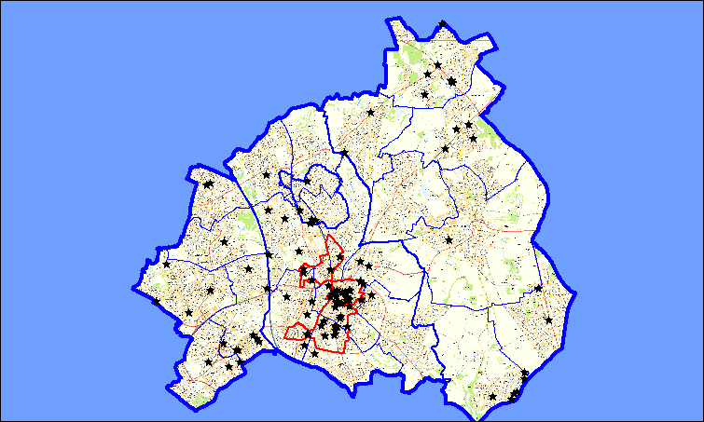
- August saw a total of 152 submissions compared to 208 in July
- 31 submissions resulted in a positive outcome. (20%)
- 116 Person ..34 Person and Vehicle .2 Vehicle

Ethnic Desc | Total
ASIAN OR ASIAN BRITISH - PAKISTANI | 16
ASIAN OR ASIAN BRITISH - BANGLADESHI | 2
ASIAN OR ASIAN BRITISH - INDIAN | 10
ASIAN OR ASIAN BRITISH - OTHER | 2
BLACK OR BLACK BRITISH - AFRICAN | 1
BLACK OR BLACK BRITISH - CARIBBEAN | 5
BLACK OR BLACK BRITISH - OTHER | 1
MIXED - OTHER | 1
MIXED - WHITE AND BLACK CARIBBEAN | 3
NOT APPLICABLE | 2
WHITE - OTHER | 4
WHITE - BRITISH | 105
(blank)
Grand Total | 152

Count of Outcome Description
Outcome Description | Total
Arrested - Consequence of Stop and Search | 17
Arrested - Unrelated Offence including Warrant / PNC | 1
Cannabis Warning | 5
Community Resolution | 6
NFA | 121
Street Summon | 2
(blank)
Grand Total | 152

The following records were scrutinised.

SSWS-L809-23549
The group were happy as this record included a detailed intelligence picture.

SSWS-M00W-23318
Intelligence mentioned but not included on record.
SSWS-7WAF-23268
This record was incorrectly sanitised as the person stopped was mentioned in the text.
SSWS-3DKQ-23156.
Stop took place in tasking area. Smell of controlled drug.

Any Other Business.
AA asked if there is a safer walking route from the University Gorway Campus into Walsall?

At the moment there is no such route.

ACTION – AM to speak to Steve Baggott at the University re the above.

BE stated that there are safe routes to schools in Walsall and suggested speaking to Adam Cross at the Council.

SS enquired about organised car theft in the Paddock area.

KF mentioned that the flasher is back in Brownhills.

Date and Time of Next Meeting.

19 November, 6pm at Walsall Police Station.

