Walsall Strategic Community Reference Group
Minutes of meeting held on Thursday 30 March 2017 at Bloxwich Police Station.
In attendance:
Elizabeth Kardynal (EK) EWA CIC
Matthew Danks (MD) Walsall College
Andy Thompson (AT) Street Teams
Helen Matthews (HM) Street Teams
Alison Davies (AD) Mencap
Peter Griffin (PG) Mencap and Walsall College/WACC
Noreen Shaw (NSh) Walsall Over 50’s Forum
Vasant Mistry (VM) Walsall Hindu Forum
Ken Ferguson (KF) Brownhills Councillor
Mr R K Mehmi (RKM) SGRT Darlaston
R Mehmi (RM) SGRT Darlaston
Jonathan Booker (JB) Walsall College
Mahmood M Sacha (MS) Muslim Welfare Society/UMO
Imran M Sacha (IS) Muslim Welfare Society
Debo Adesina (DA) WMP Chaplain
M Farhan (MF) Somalian Community
Julie Finch (JF) Pleck Community
Linda Clark (LC) Orchard Hills
Sue Evans (SE) Manor Farm Silver Scheme
Ryan Steane (RS) Brownhills West
Richard Eyles (RE) Walsall Police
Kevin Pitt (KP) Walsall Police

Apologies:
Cllr Rose Burley
Cllr A Ditta
Gary Moorcraft
Christopher Deakin
Nirmal Singh
Sue Parker
Sophie Worthington

Following the apologies and introductions, Helen Matthews and Andy Thompson gave a presentation on the work and organisation of Street Teams, who work with children and young people at risk of, and affected by, sexual exploitation, grooming and trafficking. They work with boys and girls from all backgrounds.

Helen and Andy also told the group about the CASE Project, ‘choose to end it’, aimed at tackling child sexual exploitation.

Following some questions and answers, RE explained how Black Country Neighbourhood Policing Units would, as part of WMP’s change programme, be acquiring a Locate Team, which would have the specific role of searching for and working with missing people. This more professional approach would allow officers to build relationships with people who persistently go missing, with the aim of tackling their issues and building trust and confidence. This follows a successful pilot project in Birmingham. The team will be based at Wednesfield and cover Wolverhampton and Walsall.

In the absence of the Chair and Vice-Chair, Ken Ferguson stood in to chair the meeting.

Minutes of Last Meeting and Matters Arising.
The minutes of the last meeting were read and accepted.

NSh asked about police activity around Prevent. RE replied that officers are involved in the delivery of the local prevent plan including various actions around awareness, referral of suspects, etc. This is reviewed monthly by the Chief Inspector. The force also has a prevent plan, which influences the local plan. The Counter Terrorism Unit has an officer purely to deal with Walsall referrals and to build relationships with communities through neighbourhood policing teams.

No hate crime figures were presented, however hate was discussed, there has been no significant rise, however the police expect there is still significant under-reporting.

Police Update.
RE reported that total recorded crime across the force area is up by 11% on last year, and in Walsall by 8% There has been a burglary problem recently which has been tackled locally and by the force, targeting offenders, raising crime prevention awareness, bogus callers, etc. and recruiting people to WMNow. The force burglary dwelling rate has gone up by 19%, Walsall by 11%. There has been a reduction in public place violence (e.g. pub fights, etc.), the force has seen an increase of 2.2% but Walsall a reduction of 0.6% (73 fewer victims). Business crime (inc shoplifting) has gone up in force by 12% and in Walsall by 7%. Robbery has gone up by 37% in force, 19% in Walsall, however this follows a large fall in the previous year.

JF asked about anti-social behaviour, in particular sex workers. RE replied that the local authority are looking at introducing a landlord registration scheme. The group discussed on street sex workers, RE suggested that passive community activity may be one solution. MS said that a community approach had been tried before, but had come under attack from pimps. HM said that there has been no sex worker scheme in Walsall for some time, but that a meeting was planned for the following day (Friday 31 March).

RE explained the new WMP online portal (Digital Experience for Citizens) would shortly come online, allowing online crime reporting, ‘track my crime’, making statements, etc. Separately there would be a dedicated team for high harm or complex crime.

WMP is currently recruiting new police officers, and retired officers are being encouraged to return as police staff in order to retain their skills.

Officers have now got their mobile devices, which means they do not have to spend so much time in police premises.

Regarding the recent incident in London, WMP did respond, twelve hour shifts were not put into place but a patrol plan was implemented. It has now been scaled back and we have resumed business as usual.

Stop and Search Scrutiny Panel

KP presented the following information:

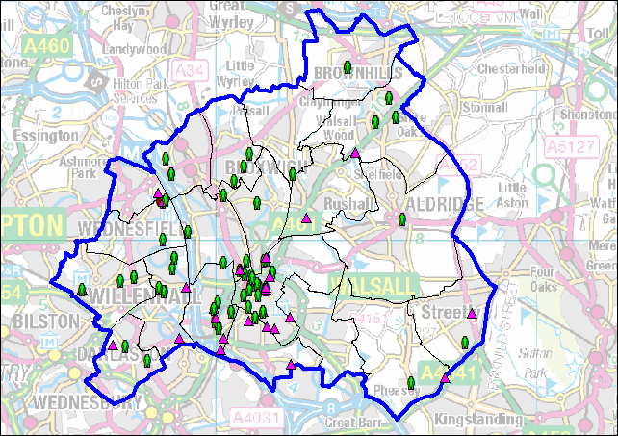

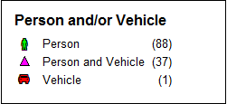

The following stop and search records were scrutinised:

SSWS-W101-48497 The group felt the outcome should be changed to no further action.
SSWS-Y9MX-48287 The group felt that the outcome should again be NFA.
SSWS-A2XT-47969
SSWS-99UP-47911
Any Other Business
There was no AOB. KP reminded members to register on WMNow.

Date of Next Meeting.
Thursday 25 May, 6pm at Bloxwich Police Station.

