Walsall Strategic Community Reference Group
Minutes of meeting held on Thursday 20 July 2017 at Bloxwich Police Station.
In attendance:
Nirmal Singh (NS) (Chair) Sikh Forum
Cllr Rose Burley (RB) Councillor Bentley/Darlaston North
Noreen Shaw (NSh) Walsall Over 50’s Forum
Ken Ferguson (KF) Brownhills Councillor
Jonathan Booker (JB) Walsall College
Vasant Mistry (VM) Walsall Hindu Forum
Mahmood M Sacha (MS) UMO
Imran Sacha (IS) UMO
Sue Parker (SP) Walsall Police
Kevin Pitt (KP) Walsall Police

Apologies:
Julie Finch
Linda Clark
Elizabeth Kardynal
Ashley Bertie (Assistant PCC)
Sophie Worthington (WMP)
Richard Eyles (WMP)

Minutes of Last Meeting and Matters Arising.
The minutes of the last meeting were read and accepted.

Police Update.
SP gave the group an update on Digital Experience for Citizens which includes a new website that will soon be going live (www.west-midlands.police.uk) which will allow the public to make general enquiries and submit incident reports online, including digital evidence and statements. The intention is to reduce the number of calls going through to 101. There have been high volumes of reporting recently (this is national) perhaps due to the warm weather and alcohol. Why reporting is so high is not really understood. Yesterday WMP took over 6500 calls, 1900 via 999 and 4700 on 101. Many calls are abandoned and we are advising people not to call 101 or 999 except when necessary.

SP went through the following slide:

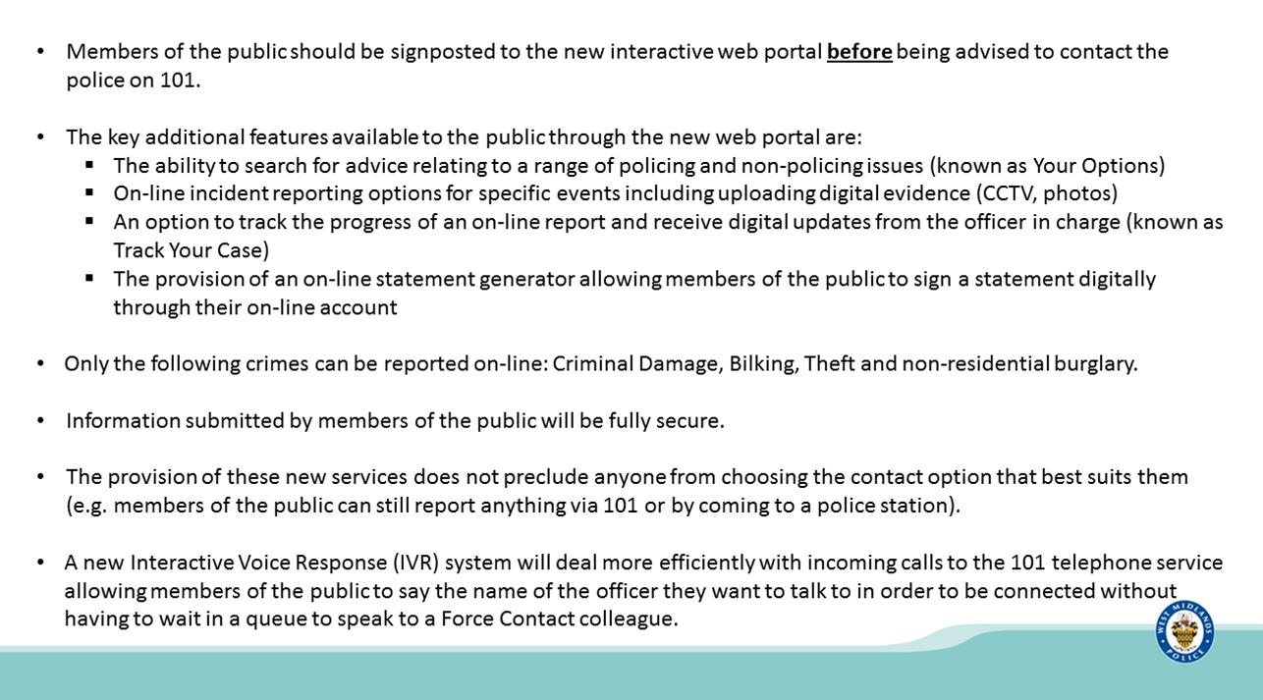

RB asked if someone will be looking at crime reports and if so what is the timescale.
SP replied yes, but we expect crime volumes to increase including some false reporting (e.g. reporting lost mobile phones as stolen to make fraudulent insurance claims). Crime reports go to an initial resolution team which is currently offering a response within 3 days, but this may be extended if there is a vast increase in reporting.

MC enquired about fraudulent claims and SP replied that while all online reports will be checked, there is no commitment to a police investigation, especially for high volume crimes. Serious crime should be reported via 101 or 999.

The 101 system will shortly include am Interactive Voice Response that will allow callers to simply state the name of the officer to be connected.

SP also update the group on a community meeting that had been held on Friday 14th July in response to concerns about some serious crimes. Crime in Aldridge is still lower than in many other areas but the community are understandably concerned. SP explained that there are currently 53 officers committed to neighbourhood teams with the Neighbourhood Policing Unit having 163 officers, supported by headquarters units such as response, CID, operations, etc.

RB asked how the neighbourhood officers are spread across the borough. SP replied according to the typography model, whereby neighbourhoods are graded according to crime levels, deprivation, etc. and resourced accordingly. Low crime areas tend to have a higher proportion of PCSO’s.

Neighbourhood teams work a 3/3/3 shift pattern, i.e. 3 earlies, 3 lates and three days off. If a particular team is not on duty then a neighbouring team will pick up urgent calls and flex to provide for high crime/demand areas. Police visibility is a challenge.

RB enquired about knife crime, what else can we do to get the message out to young people. SP replied that WMP has experienced the national increase in knife crime, mainly among young people, and is responding with education (e.g. PC Rob Pedley) and work with partners (e.g. youth justice and street doctors), enforcement with environmental health, etc. Also looking at peer mentoring within schools.

KF asked if more stop and search would help. SP replied that police officers have the power to stop and search anyone suspected of carrying a weapon but that stop and search has been misused in the past so officers must now have understanding of the impact on the community and the individual. Officers need tangible evidence.

KF enquired if the recent violent incidents in Pelsall and Walsall Wood were linked. SP replied yes, a number of arrests had been made and several people were on bail as investigations continued.

Stop and Search Scrutiny Progress with Assistant PCC Ashley Bertie.
As Mr Bertie was unable to attend this item was postponed to a later meeting.

Stop and Search Scrutiny Panel.
KP presented the following information:

WS Stop and Search 1st June -13th July

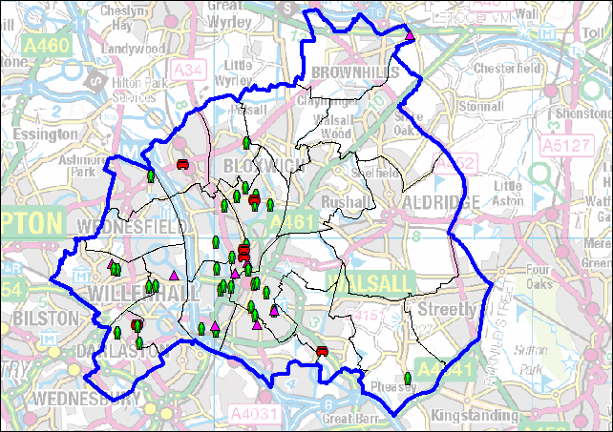

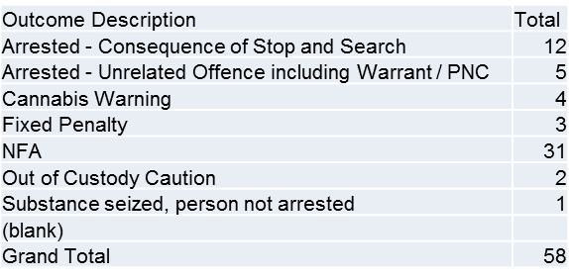

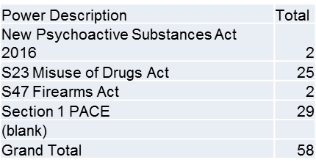

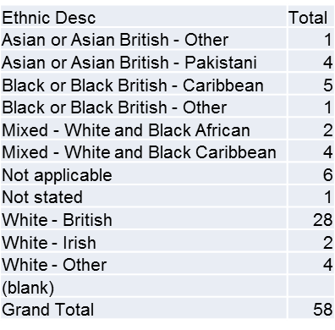

The following stop and search records were viewed and scrutinised:

SSWS-N6DY-51797
SSWS-VRXM-51587 – the group queried that the house number was visible.
SSWS-81H5-51306 – the group noted that the vehicle number plate was visible.
SSWS-ZPFN-51278
SSWS-U7RA-51647

The two queries will be raised with the force co-ordinator.

Any Other Business
AZ enquired about an action in the last minutes regarding an update around prostitution. KP replied that he had spoken to Nicola salt from Changing Lives, a charity which has applied for lottery funding to set up a project to work with sex workers, they are very hopeful and expect a decision in August. Nicola will be invited to the next meeting.

RB told the group about a community event in Darlaston this weekend.

MS thanked the police for their support around recent mosque attacks.

KF raised parking issues around Shire Oak school.

Date and Time of Next Meeting.
6pm on 21 September at Bloxwich Police Station.

