Walsall Strategic Community Reference Group
Minutes of meeting held on Thursday 25 May 2017 at Bloxwich Police Station.
In attendance:
Nirmal Singh (NS) (Chair) Sikh Forum
Manyata Patel (MP) Hindu Forum
Cllr Rose Burley (RB) Councillor Bentley/Darlaston North
Sandeep Singh Sohal (SS) Sikh Forum
Sonia E McLaughlin (SM) Walsall Black Sisters Collective
Eve Lewin (EL) Walsall Black Sisters Collective
Praful Nathwani (PN) Hindu Forum
Elizabeth Kardynal (EK) EWA CIC
Noreen Shaw (NSh) Walsall Over 50’s Forum
Ken Ferguson (KF) Brownhills Councillor
Mr R K Mehmi (RKM) SGRT Darlaston
Jonathan Booker (JB) Walsall College
Linda Clark (LC) Orchard Hills
Ryan Steane (RS) Brownhills West
Sue Ball (SB) Places of Welcome
Sue Parker (SP) Walsall Police
Richard Eyles (RE) Walsall Police
Pip Lally (PL) WMCTU
Eammon Hall (EH) WMCTU
Kevin Pitt (KP) Walsall Police

Apologies:
Julie Finch
Sue Evans
Farhan Mohamed

Following introductions and apologies the Chair proposed a one minute silence in memory of the Manchester bombing victims.

Minutes of Last Meeting and Matters Arising.
The minutes of the last meeting were read and accepted.

Sue Ball, Places of Welcome.
SB explained how Places of Welcome had begun in Birmingham with a conversation about how welcoming the city was, three years later there are around 50 places of welcome in the Black Country including 15 in Walsall involving faith groups, libraries and community associations. They offer an accessible place at a regular time and are open to everyone. To find out more visit http://www.placesofwelcome.org/

Police Update.
Opened with a West Midlands Counter Terrorism Unit update from Prevent Officers PL and EH who explained the meaning of ‘Prevent’ and it’s place in the government’s counter-terrorism strategy, CONTEST, which aims to reduce the risk of terrorism in UK and overseas territories. The UK’s security state has been raised to critical, meaning that an attack is imminent.
The Contest strategy promotes co-operation between organisations and the public and is in four parts, Prevent, Pursue, Protect and Prepare.

Prevent operates in the pre-criminal space and aims to safeguard individuals, preventing people from becoming involved in acts of terror.

Pursue – is the investigation of terrorist crimes.
Protect – is the protection of infrastructure (hospitals, airports, roads, etc.) from attack.

Prepare – how the public services react to an attack.

Prevent relies on the links with communities and referrals from Walsall’s diverse community reflects this. Many referrals come from educational establishments. It is possible to report suspicions via the anti-terrorist hotline 0800 789 321 or the red button on the West Midlands Police Website.

MP asked how effective the strategy was and EH replied that he works with a ‘Channel Panel’ to look at individuals’ vulnerabilities with their consent. If there is no consent then enforcement may be the only option.

RB mentioned that there had been some criticism of the Prevent strategy. EH replied that there was always room for improvement.

Terrorism is not just international (e.g. IS and Al Qadea) but also domestic, e.g. the extreme right wing. The press and media play a role.

RB asked what is being done to protect and reassure communities. SP relied that the police response was swift, officers were immediately placed on twelve hour shifts so that there were more officers on duty and they were more visible. This is to be reviewed nest week. Patrols have concentrated on crowded and iconic places, transport and entertainment venues, and other vulnerable sites (e.g. Walsall rail and bus stations, Crown Wharf and Saddlers Centre), working with the management and security of those places. Pre-prepared plans under Operation Temperer were initialised to give the police opportunity to increase armed response capability. There are now ten Armed Response Vehicles out at any one time. Temperer also gives the police opportunity to add some military personnel to guard vulnerable sites. There are currently more unarmed staff in Walsall on high visibility patrol.
No increase in hate crime has been reported and it is now prioritised for investigation.

KF enquired about the reported increase in crime. SP replied that yes there has been an increase in reported crime locally and nationally, partly due to a change in Home Office counting rules. There has been an increase in vehicle crime locally. The police are aware of local challenges and committed to keeping Neighbourhood Policing Teams in place.

EK asked if WMP had supported anyone else or benefitted from extra officers. SP replied that Walsall had benefitted from extra personnel.

EK then asked about the protocol for hate crime. SP replied that it is reviewed each day and crimes were prioritised using the THRIVE+ model. The police are currently giving priority to investigating hate crime.

Our intelligence officers monitor social media and note broad changes but cannot pick up everything. We still rely on the public to report what they see and hear.

Stop and Search Scrutiny Panel.

KP presented the following information:

Walsall Stop and Search for April 2017.

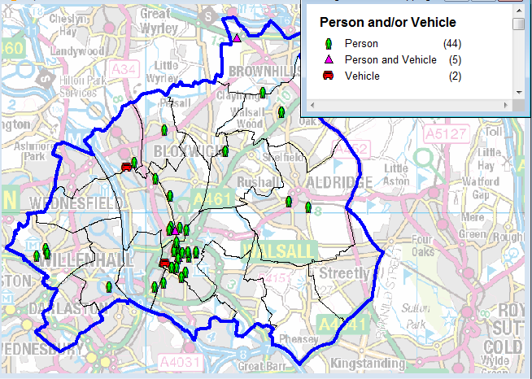

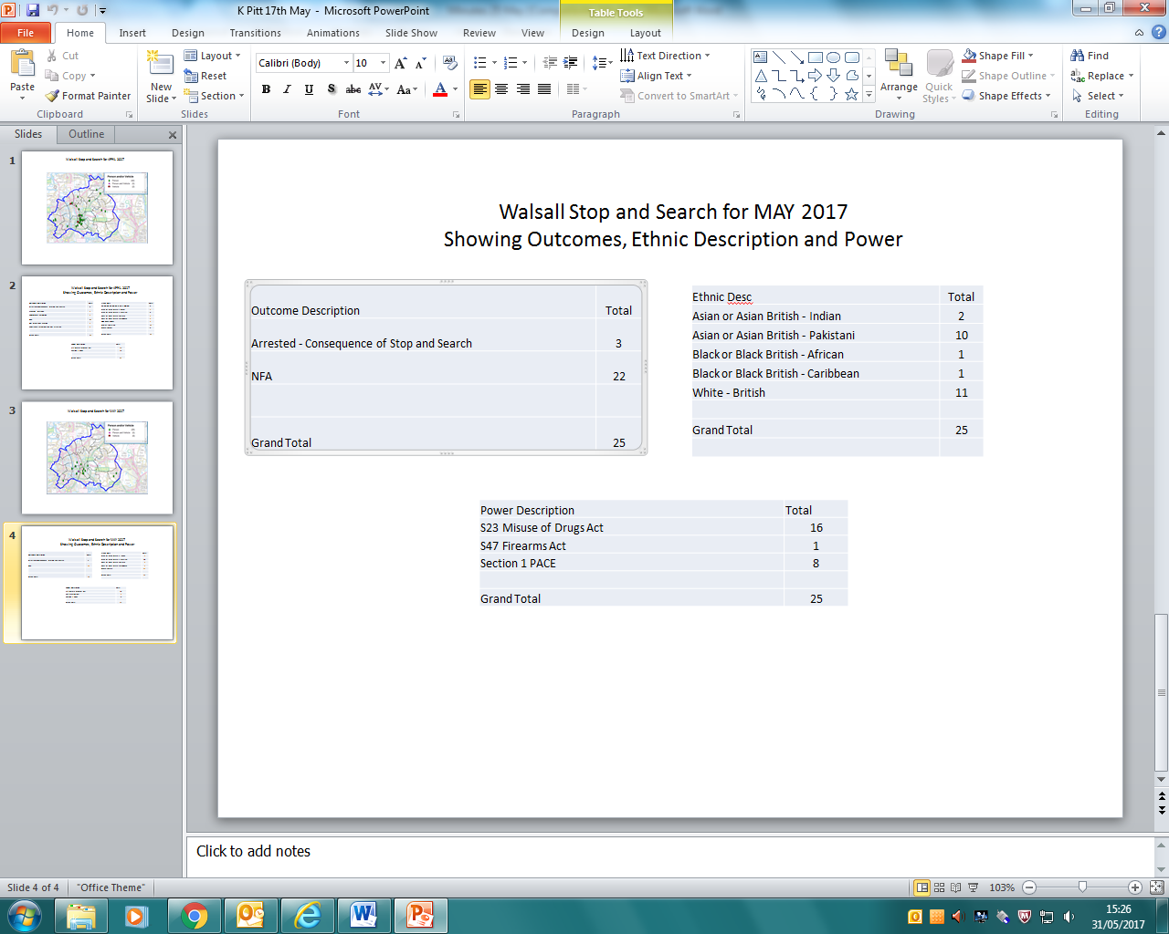

The following records were scrutinised:

SSWS-WDCR-50158
SSWS-L0UC-49766
SSWS-5C9Y-49737
SSWS-SKRQ-49649
SSWS-U7S6-49587

No concerns were raised.

Any Other Business

EL asked what the police were doing about prostitution. SP replied that we were still in discussion with our partners regarding this.

ACTION – KP/SP to bring an update to the next meeting if available.

RKM informed the group that a multi-cultural society festival would be taking place on 22 July at All Saints Church in Darlaston. Details to follow.

Date and Time of Next Meeting.
Thursday 20 July, 6pm at Bloxwich Police Station.

