Walsall Strategic Community Reference Group
Minutes of meeting held on Thursday 21 November 2017 at Bloxwich Police Station.
In attendance:
Nirmal Singh (NS) (Chair) Sikh Forum
Ken Ferguson (KF) Brownhills Councillor
Jonathan Booker (JB) Walsall College
Vasant Mistry (VM) Walsall Hindu Forum
Mahmood M Sacha (MS) UMO
R K Mehmi (RM) SGRTD
Cllr A Ditta (AD) Palfrey Councillor
Linda Clarke (LC) Orchard Hills
Phil Holmes (PH) Orchard Hills
Ryan Steane (RS) BCU
Kevin Pitt (KP) Walsall Police

Apologies:
Julie Finch
Imran Sacha
Rose Burley
Stephanie Hayes
Susan Braidley
Arfan Zaman
Sophie Worthington (WMP)
Sue Parker (WMP)

Minutes of Last Meeting and Matters Arising.
The minutes of the last meeting were read and accepted.

Retired West Midlands Police Dogs Benevolent Fund
Former Police Authority member Phil Holmes kindly gave a short presentation about the Retired West Midlands Police Dogs Benevolent Fund which helps to look after retired police dogs, especially with vet’s fees as they are not insurable and injuries, age, etc. can lead to them requiring more attention than other dogs. Many retired dogs remain with their police handler after retirement and they pay £50 per annum to be a member of the Fund, which will cover up to £500 p.a. in vets’ bills. The Fund, which raises money by attending events such as Cruft’s dog show, is planning on becoming a registered charity shortly.

More information can be found on the Fund’s Facebook page (www.facebook.com/RetiredWMPD/) and on Twitter (https://twitter.com/retiredwmp_dog)

The WMP kennels are currently seeking to recruit puppy walkers.

Police Update.
Unfortunately no senior police officers were able to attend due to the meeting clashing with a Locality Panel event. Therefore the police update was given by KP who began by explaining WMP’s week of action on knife crime. Officers are going out giving talks to young people about the consequences of carrying a knife and how one blade can affect many lives. There is also a knife amnesty with knife bins where knives can be surrendered in several areas. The police have several ‘all out’ days recently, with officers and staff tackling various areas of demand, e.g. logs and warrants.

At the moment, crimes of particular concern to the police include burglary and vehicle crime. KP gave some basic crime prevention advice, i.e. not leaving items on show in cars, making sure doors and windows are locked before going out, and explained that WMP will shortly be launching it’s seasonal darker nights campaign before the clocks go back as well as a ‘mischief week’ campaign ahead of Halloween and school half term.

Concern was raised about the difficulty of getting members of the public to attend meetings such as the SCRG. PH said that this was a longstanding problem, the old Police Authority used to hold consultative meetings, some of which were stopped due to lack of attendance.

KF enquired what was happening with the neighbourhood watch in Brownhills. KP replied that this was currently being handled by volunteers from Rushall, Shelfield and Pelsall Neighbourhood Watch, who were hoping to get local involvement in setting up community-led meetings.

The meeting discussed the new Locality Panels, which are being set up by Walsall Council and local partners.

Stop and Search Scrutiny Panel

KP presented the following information.

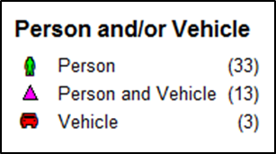
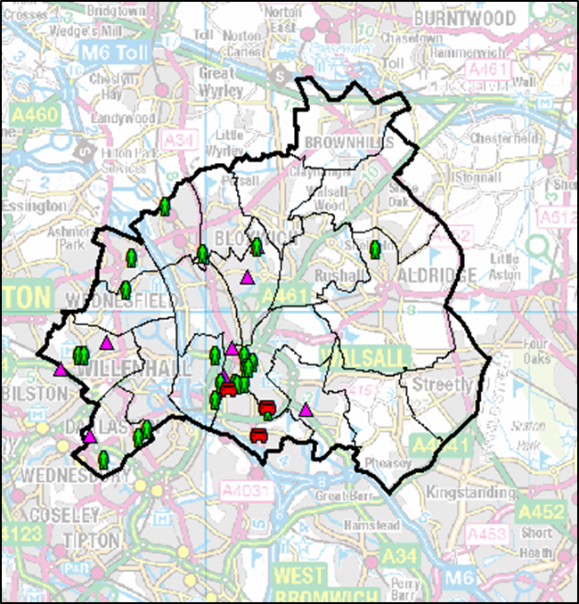
Stop and Search (August 2017)

Proportionality and Outcome Description
August 2017

Object Description and Power Description
August 2017

The following Stop and Search records were scrutinised.

SSWS-EY-53725
SSWS-D1IO-53535
SSWS-X81P-53393
SSWS-NW-53190
SSWS-WILO-53082

Any Other Business

AD commented that drug and prostitution problems were getting worse in Palfrey. There are many serious issues that require action, e.g. an increased police presence.

LC mentioned parking problems around Queen Mary’s Grammar School. Can the police take action?

KF enquired as to how many police officers were now in Walsall? KP replied that this was difficult to assess as many functions, e.g. response, investigation, PPU, etc. are force functions and not run locally.

ACTION – KP to circulate information on police numbers in Walsall.
Update 25/9/17: KP has circulated the below information obtained from a FOI request made by Walsall Borough Neighbourhood Watch Association.

West Midlands Police Freedom of Information

06/09/2017 9234/17

Comparative numbers of officers serving the Walsall area for years 2013-2017 inclusive WALSALL NEIGHBOURHOOD OFFICERS 2013 – 2017
Post Rank | 01/04/2013 | 01/04/2014 | 01/04/2015 | 01/04/2016 | 01/04/2017
Insp | 3 | 3 | 3 | 0 | 3
Sgt | 18 | 15 | 16 | 14 | 16
Con | 72 | 75 | 65 | 59 | 62

Please note: The above is purely for Police Officers classed as Neighbourhood Policing Teams (plus Neighbourhood Taskforce since November 2016). Figures for officers covering Walsall will be much higher as it does not include:
• Response functions (& Force Support since ‘Nov 16)
• Roads Policing
• Investigations
• Partnership
• CAPT (Community Action Priority Team) / Local Priority Teams (pre-Nov 16)
• Offender Management

It only includes PC to Inspector, ranks above that are not Neighbourhood specific.
Please see below for PCSO figures:
Walsall NPU Post Rank | 01/04/2013 | 01/04/2014 | 01/04/2015 | 01/04/2016 | 01/04/2017
PCSO | 48 | 49 | 49 | 41 | 37

Date and Time of Next Meeting.
The next meeting will be held on Thursday 23 November, 6pm at Bloxwich Police Station.

