Walsall Strategic Community Reference Group
Minutes of meeting held on Thursday 19 May 2016 at Walsall Police Station.
In attendance:
Nirmal Singh (NS) Sikh Forum
Alison Davies (AD) Mencap
Peter Griffin (PG) Walsall College
R K Mehmi (RM) SGRT Darlaston
Cllr Ken Ferguson (KF) Brownhills Councillor
Sandeep Singh Sohal (SS) Walsall Sikh Forum
Julie Finch (JF) CUSP
Bill Ellens (BE) CUSP
Elizabeth Kardynal (EK) EWA CIC
Cllr Rose Burley (RB) Councillor Bentley and Darlaston North
Cllr A Ditta (AD) Councillor Palfrey ward.
M M Sacha (MS) Muslim Welfare Society/UMO
Imran Sacha (IS) Darlaston Boys’ Club.
Andy Bullman (AB) Walsall Police
Kevin Pitt (KP) Walsall Police

Apologies:
Nasar Iqbal
Ryan Steane
Vasant Mistry
Ashley Lovell
Gary Moorcraft

Minutes of Last Meeting.
The minutes of the last meeting were read and accepted.

BE announced his retirement from the group, to be replaced by JF. The Chair thanked Bill for his commitment and wished him the best for the future.

Police Update
AB presented the draft local delivery plan to the group. He also explained how the police are working with the local authority and Youth Officers to divert young people, two Youth Offender Officers are being funded by Safer Walsall Partnership to work with offenders across the borough. 42 young people have been worked with during the last three months and so far none have re-offended.

A discussion as to why young people offend took place.

JF pointed out that sex workers are returning to the Pleck area causing ASB, kerb crawling. AB will ensure the problem is addressed (Insp Adam Reynolds to contact JF).

Active citizens funding will soon be available for groups who currently do not engage with the police. The leads are Chief Inspector Mark Griffiths and Sgt Nick Morton.

Early Help – the police are working with the local authority to help children get a better upbringing and avoid becoming involved in crime or anti-social behaviour.

AB also explained how one WMP2020 programme will involve dedicated domestic abuse managers. There will be other programmes including diversion for offenders.

There was a discussion about young offenders and the closure of youth centres.
AB explained how many calls to the police do not involve crime but ‘vulnerability’ and that the police are working with the local authority, clinical commissioning group and other partners to address mental health, simplifying access to services and setting up a new mental health strategy in an attempt to reduce the demand on police resources and assist the person to get the most appropriate help.

MMS enquired about Prevent. AB explained that not just the police but all public bodies have responsibility to prevent people becoming involved in terrorism. All have to have policies.

WMP2020 – AB explained that there will soon be a new structure for neighbourhood policing and that he will probably have further details for the next meeting.

Stop and Search
KP gave the following information for the period 1 April to 16 May.

Map of stop and search procedures.

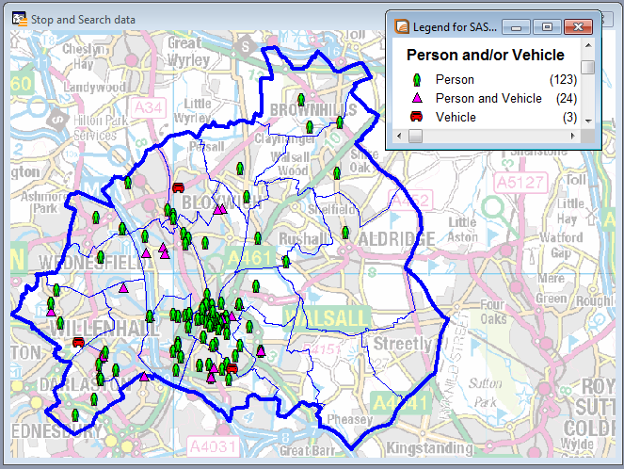

Outcomes and Ethnic description of person.
Outcome Description | Total
Arrested - Consequence of Stop and Search | 28
Arrested - Unrelated Offence including Warrant / PNC | 5
Cannabis Warning | 7
Community Resolution | 6
NFA | 102
Out of Custody Caution | 1
Street Bail | 1
(blank)
Grand Total | 150
Ethnic Desc | Total
ASIAN OR ASIAN BRITISH - PAKISTANI | 15
ASIAN OR ASIAN BRITISH - INDIAN | 10
ASIAN OR ASIAN BRITISH - OTHER | 1
BLACK OR BLACK BRITISH - AFRICAN | 2
BLACK OR BLACK BRITISH - CARIBBEAN | 7
BLACK OR BLACK BRITISH - OTHER | 1
MIXED - OTHER | 3
MIXED - WHITE AND ASIAN | 2
MIXED - WHITE AND BLACK CARIBBEAN | 3
NOT APPLICABLE | 3
WHITE - OTHER | 10
WHITE - BRITISH | 91
WHITE - IRISH | 2
(blank)
Grand Total | 150

The following stop and search records were scrutinised.

SSWS-NOYD-37558
SSWS-8XBI-37490
SSWS-67EG-37257
SSWS-LWFV-37124.

Modern Day Slavery
Sgt Gary Iliff gave a presentation on MDS, explaining Operation Sentinel objectives and going into detail about HMO’s (houses of multiple occupation) which are closely linked with modern day slavery.

- A HMO is an entire house or flat which is let to:
- At least 3 tenants,
- Forming 2 or more households,
- Sharing facilities such as toilet, bathroom or kitchen facilities with other tenants.

A DVD is being produced to raise taxi drivers’ awareness of child sexual exploitation.

Any Other Business
RM told the group about a community event being held in Darlaston on Saturday.

EK mentioned a Polish Picnic being held in Caldmore Community Garden, also on Saturday.

MS informed the group that Ramadan would begin on 5th or 6th June and that additional prayers would be taking place. He asked for extra police attention to mosques.

SS mentioned that he was involved in a tournament being held at Aston Villa Playing Fields on 28 and 29 May.

Date of Next Meeting.
The next meeting will be held on Thursday 14 July, 6pm.

